Handbook.

CLEANING GUIDELINES TO PREVENT THE SPREAD OF COVID-19
As we have to thoroughly clean all crockery, glassware, cooking utensils, and anything likely to have been touched by visitors at each changeover we have only left in the house enough of these items for your use. The rest has been packed away but if you need more please let me know.
We have also removed games (scrabble, cards, carpet bowls, backgammon and board games etc.) as well as videos. Again please let me know if you would like to use any of these and I will let you have them (we will have to thoroughly disinfect them before the next guests arrive).
Some of our ornaments have also been removed for the same reason. I hope you will still find the house comfortable and trust you will understand our reasons for taking this action.
DOGS
From 1st May to 30th September dogs are not allowed on the West end beaches. You may take them on to the beach once you have passed the Lifeboat Station.
You can also take them on the the beaches at the East end of the promenade (the Beeston Hump end).
Other suggested dog walking areas nearby: Pretty Corner Woods; Beeston Common (over roundabout towards Cromer, about ½ mile); Franklins Hill (off Hooks Hill Rd – see map at back of information file).
Please do not allow your dog to foul the garden.
We have been asked to remind you to please clean up after your dog, should it foul the pavements or footpaths. THIS INCLUDES THE LANE AT THE BACK OF THE HOUSE.
Thank you for your co-operation.
TV INSTRUCTIONS
Use black Samsung remote (with just one red button at top).
Press red button to switch on. Use P button with up and down arrows to choose programme.
TO PLAY DVDS
Use Blue Ray box on bottom shelf of tv stand. (Samsung remote with two red buttons at the top is the one to use for this).
DVD INSTRUCTIONS
Using grey remote: Press blue button twice.
On Samsung remote: press small arrow under start button (top left hand side) to open . Press again to close.
Press square to stop dvd. Press twice to go back to beginning.
Press small arrow to eject. Press again to close.
Press blue button to return to HMDI. Press again to get back to TV
Switch off DVD machine by pressing on/off button on Samsung (left hand side)
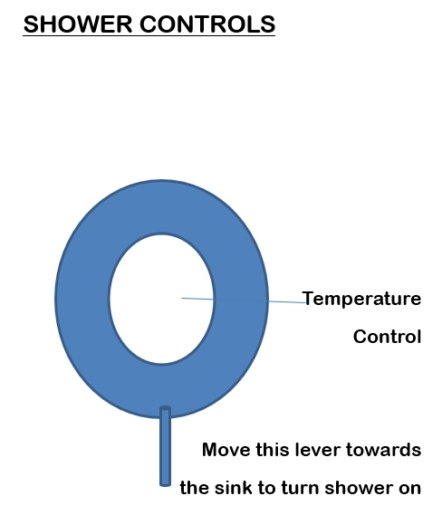

Protecting the Environment
We are committed to protecting the environment and you can help in the following ways:
RECYCLING
There is a swing bin beside the tumble dryer for recyclable items. These are: paper (including newspapers, magazines etc), card, aluminium and steel cans (please rinse out cans where possible), plastic pots e.g. yoghurt pots, glass jars and bottles. The bin will be emptied into the green wheelie bin behind the garage (items emptied loose into the bin, not in plastic bags).
All other general refuse, should be put in the swing bin beside the sink.
ENERGY CONSUMPTION
Wherever possible we use low energy light bulbs.
During the winter months the central heating will be on. There is a thermostat in the hall. When you retire for the night please turn the thermostat down to 14C; you can turn it up to 20C during the day. The radiators in each room can also be adjusted. If the house gets too warm please turn the thermostat down – do not try to cool the house down by opening doors and windows.
OUT AND ABOUT
Enjoy the many walks in and around Sheringham; take the Coasthopper bus along to Cley nature reserve, or on to Blakeney and Morston (where you can go on a seal trip). Details are in the leaflet rack or availablel at the tourist information which is beside the steam railway. Please use the litter bins and “scoop the poop”; respect the country code and help us to keep Sheringham special.
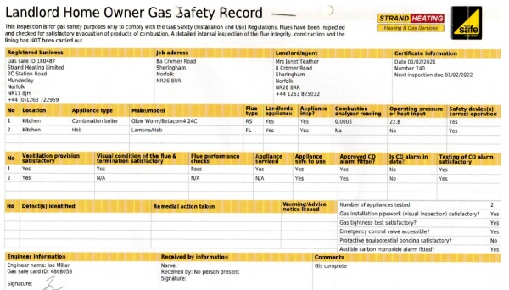
FIRE SAFETY RISK ASSESSMENT FOR GLENDALOUGH, 8A CROMER RD. SHERINGHAM
There is a smoke detector fitted in the hall outside the downstairs bedroom. This is checked monthly.
The main exit from the building is by the door into the hallway. Spare keys for this are kept on the hall table.
The building can also be exited by the patio doors in the dining room. Spare keys for this are kept on the radiator shelf beside the door.
Please ensure that the keys are left in the external doors at night so that the doors can be quickly opened in case of emergency.
SMOKING; THIS IS A NO SMOKING PROPERTY.
Smokers are asked to smoke outside.
BEDROOMS: Please do not place any items on top of lamps and please do not cover radiators.
KITCHEN: A fire blanket is sited on the wall to the left of the kitchen sink and a fire extinguisher is also on that wall. Tumble Dryer: please remove fluff from sill of drum when emptying tumble dryer.
LOUNGE: Visitors are asked to exercise special care if using the open fire in the lounge. A spark guard, nursery guard and hearthrug are provided. The fire should NEVER be left unattended without first placing the spark guard in front of it. Please ensure that the fire is dying down and the guards are in place before retiring for the night. The chimney is swept at least once a year. Please do not place any items on top of lamps. The only candles that should be used are tea lights.
DINING ROOM: Please do not place any items on top of lamps. The only candles that should be used are tea lights.
The fusebox is in the lobby over the door leading to the dining-room and lounge. There is a torch in the food store cupboard in the lobby (opposite the fuse box).
IMPROVEMENTS
1992 Upgrade to “3 key commended”
1993 Gas water heater installed to provide instant hot water
1994 Major building improvements to create ground floor single bedroom, additional toilet and wash basin, new bigger bathroom, stairs re-sited to give separate access to each bedroom upstairs; fitted kitchen installed; UPVC patio doors fitted.
1995 Shower fitted in bathroom; replaced carpet in lounge/dining room; replaced sofa bed with spring-based type; dining table replaced with larger oak table.
1996 New frig; 2 new easy chairs; garden furniture.
1997 Microwave installed; Parker-Knoll chairs re-upholstered.
1998 UPVC windows fitted in bathroom and family bedroom.
1999 UPVC windows fitted in lounge and double bedroom.
2000 Freezer provided
2001 Door re-instated.
2002 Gas central heating installed.
NEW RATING OF 3*
2003 Family bedroom refurbished; cutlery upgraded
2004 New kitchen installed; washing machine, dishwasher and tumble-dryer installed. Storage space in lobby converted to pantry. Cupboard built under stairs for utility storage. New sofa bed in lounge.
UPGRADED TO 4*
2005 Fitted wardrobe in small bedroom removed to create more space. Bedroom redesigned and refurbished. Garden furniture upgraded to teak extending table, chairs & parasol. New sofa installed. Ironing board, iron, hairdryer and fire blanket renewed. UPVC window installed in hall.
2007 Bathroom upgraded
Double Bedroom upgraded and converted to twin bedroom
2008 New front door.
Family bedroom refurbished.
2009 Windows replaced in kitchen and single bedroom. Kitchen refurbished. New flat screen tv.
2010 New curtains in lounge; blind fitted in small toilet.
2011 New condensation Central Heating Boiler installed.
2012 Bathroom redecorated.
2013 New large toaster. New wardrobe in twin room
2014 Flooring in hall and kitchen replaced.
2015 Wide screen digital tv.
2016 New carpet in single room; new kitchen floor
2017 Entrance hall and passage redecorated and upgraded; new mattress on double bed; lamps and light fittings updated in lounge and dining room; bedding and curtains upgraded in twin room.
2018 New Fridge/freezer. New garden furniture. New crockery.
2019 New central heating boiler installed.
Bedding upgraded in family bedroom.
New dishwasher installed
Hanging rail replaced by wardrobe in downstairs bedroom.
2020 Family bedroom – décor upgraded. New carpet
New stair carpet.
New flooring in downstairs w.c.
Renew sofa and easy chairs in lounge.
New dishwasher installed.
New hob; upgraded oven; upgraded microwave.
2021 Lounge and dining room: décor upgraded.
Roller blinds fitted to lounge windows.
New wardrobe and dressing table in twin bedroom
New tumble dryer installed
New flooring in lounge and dining room
Electrical supply upgraded and new consumer unit installed

INVENTORY
BEDROOM 1 Double bed; single bed; 1 chest of drawers; 2 bedside cupboards; 3 table lamps; mirror; chair.
Cot stored in walk-in wardrobe
BEDROOM 2 Twin beds; wardrobe; chest of drawers; bedside cupboard; 1 table lamp.
BEDROOM 3 (Ground Floor) Single bed; chest of drawers; chair; mirror; wardrobe; table lamp
BED LINEN Duvets and two pillows per person with extra blankets.
Bed linen supplied. Spare bed-linen is stored in storage bags underneath the beds.
KITCHEN Electric cooker, fridge/ freezer, washing machine, dryer, dishwasher, microwave, electric kettle; toaster; coffee percolator; 4 saucepans, 2 frying pans;1 small casserole; a large cooking pot; roasting tin; assorted baking tins; 2 pyrex dishes; 2 pyrex pudding basins; one ovenware dish; measuring jug; gravy boat; colander; toast rack; butter dish; 2 tureens; cheese grater; meat serving dish; scales; kitchen utensils; assorted knives; chopping board; bread bin; bread board; cheese board; rolling pin; pastry cutter; corkscrew; tin-opener; teapot; sugar bowl; cream jug; 2 jugs ;1 fruit serving dish; 2 ramekin dishes; water jug; 2 x 8” plates; 3 tablespoons; assorted trays. 8 each of the following: 12” plates; 6” plates; bowls; mugs; egg cups; 6 steak knives and forks; knives, forks, dessert spoons; teaspoons; soup spoons; mugs; glass tumblers, wine glasses, tankards, sundae glasses, 8 additional knives & forks, additional teaspoons. Laundry basket, broom, dustpan & brush, washing up bowl, draining rack, bucket, mop, clock, chair,
DINING ROOM Table, 8 chairs; easy chair; additional drop-leaf table; bookcase containing place mats; coasters, dvds. Radio with bluetooth; reading lamp; pictures; ornaments. blanket chest (containing bed-linen for sofa bed);
LOUNGE 1 sofa-bed; 1 sofa; 2 easy chairs; nest of tables; side table with games underneath; television; 4 table lamps; pictures; wall plates; ornaments; brass fender., video
CUPBOARD Ironing board, iron, vacuum cleaner, clothes drying rack,
UNDER STAIRS hair dryer, fire guard, dustpan, brush, cleaning materials
PANTRY Veg rack, cake tins, wine rack, spare light bulbs, candles, torch
Tablecloths
HALL Coat stand, table.
GARDEN Table, chairs, parasol. (Barbecue on request)

